- Review your Cash Allocation Report (Financial Statement in General Ledger), the total unallocated cash, utility cash clearing and accounts receivable cash clearing accounts should equal zero. 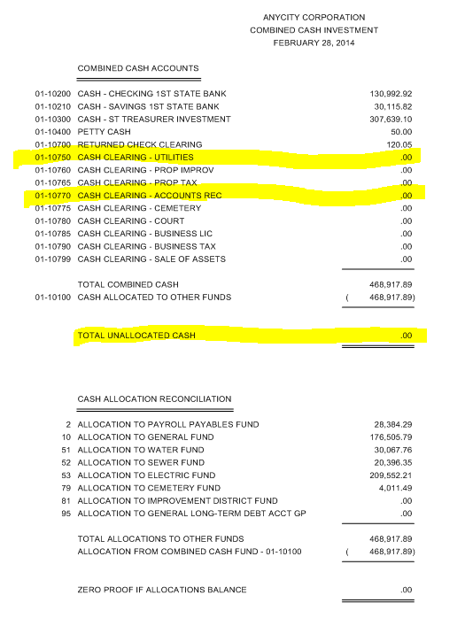

- If the unallocated cash does not balance, run “Create Allocations” in the General Ledger. If it still does not balance, look for journal entries entered to a cash clearing account.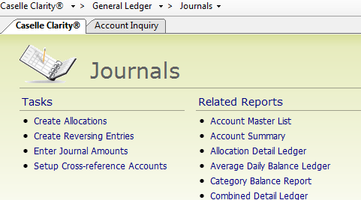

- If the Utility Cash Clearing account does not balance: 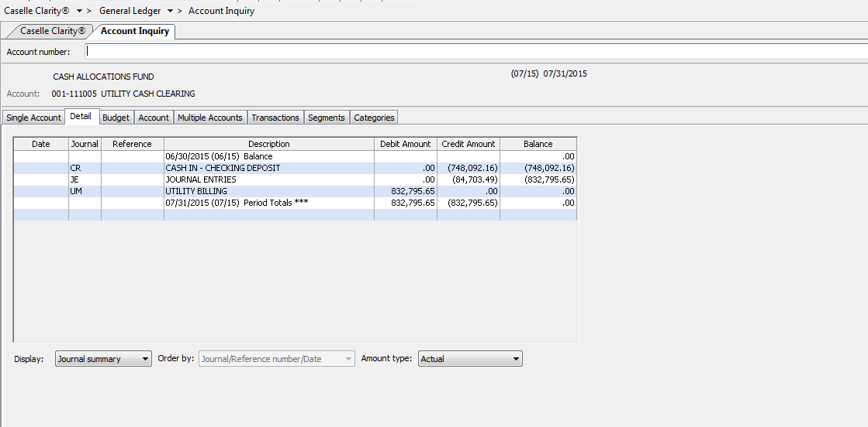

  - Look in account inquiry for possible journal entries
  - Verify journal totals equal sub-modules and that sub-modules are updated
  - Run reports to make sure sub-modules tie to each other
    - Cash Receipt – Receipt Register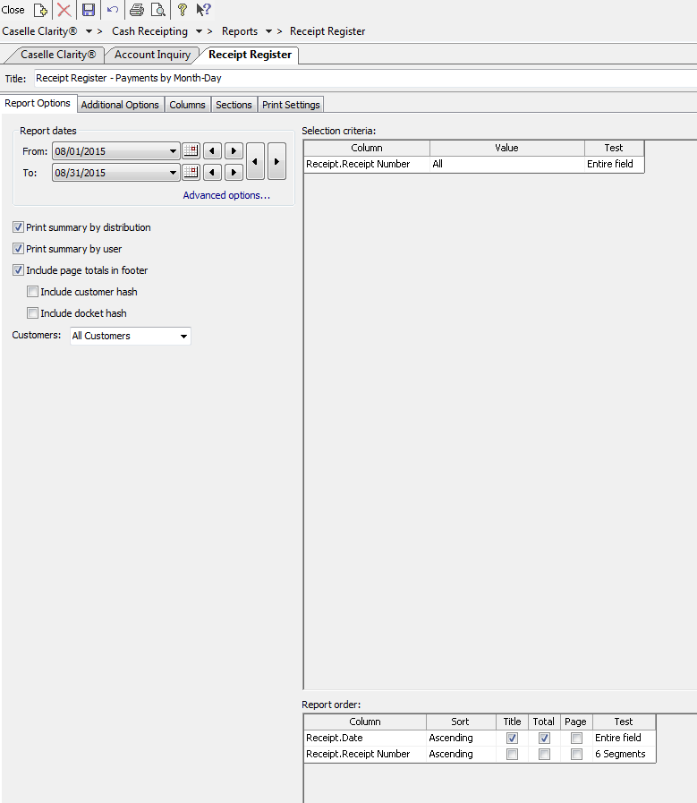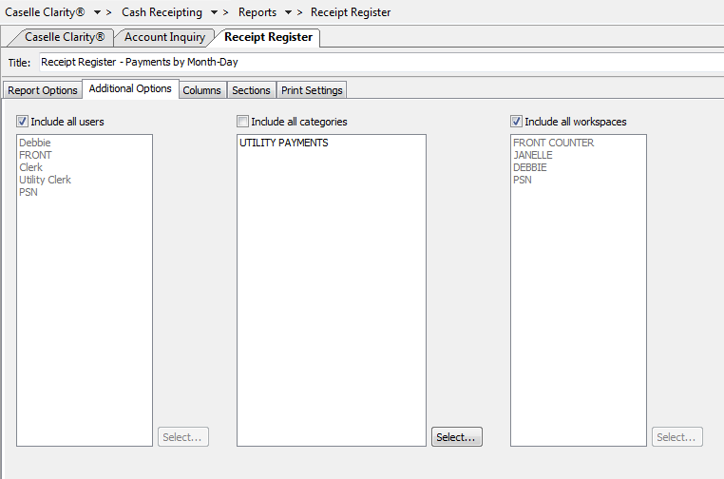 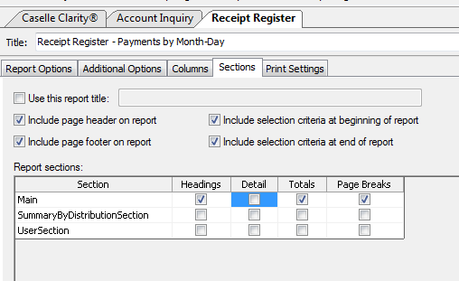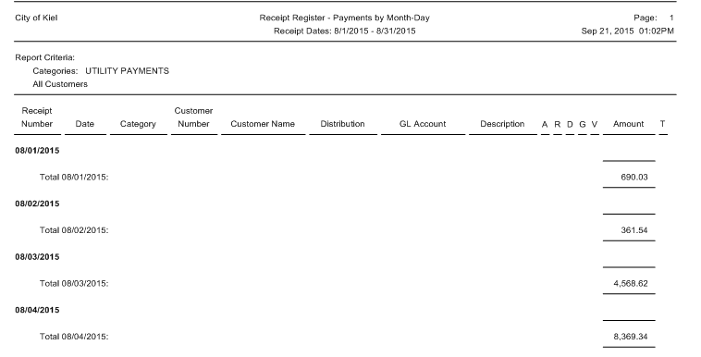
    - Utility Management - Transaction Register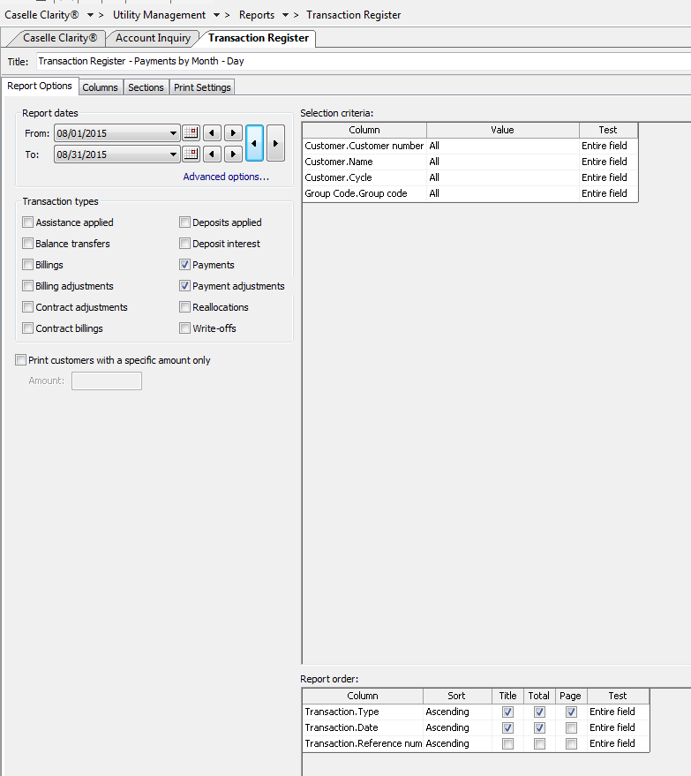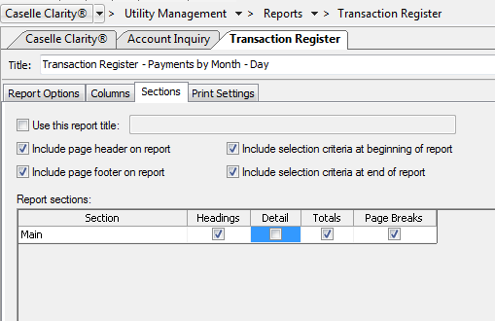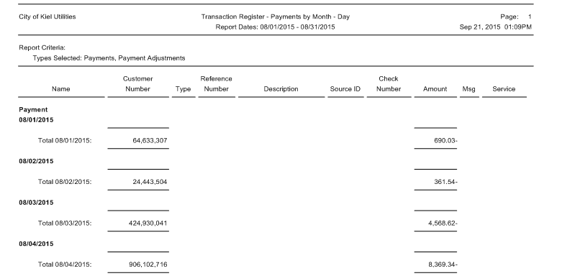
- Accounts Payable should zero out or tie to the Unpaid Invoice Report each month
  - Review in Account Inquiry or create a report to show balance of all fund account payable accounts each month (ie Trial Balance) 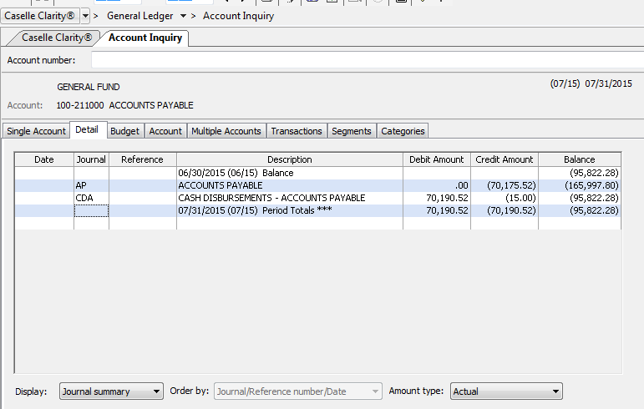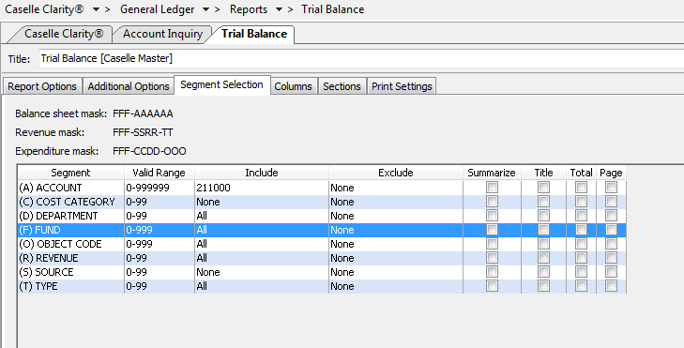
  - Run the Unpaid Invoice Report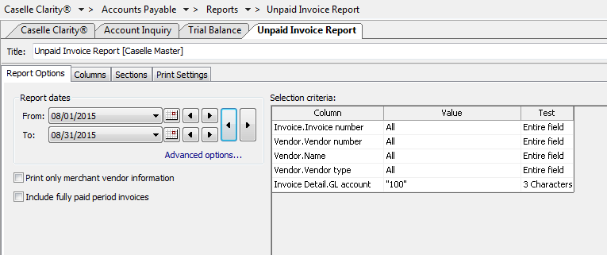
- Tie out Payroll liability accounts each month. They should zero out or you should be able to identify the balance.
  - Examples – Federal Withholding, Social Security/Medicare Withholding , State Withholding, Health Insurance, Garnishments
Review in Account Inquiry or create a report to show balance of all payroll liability accounts each month (ie Trial Balance) 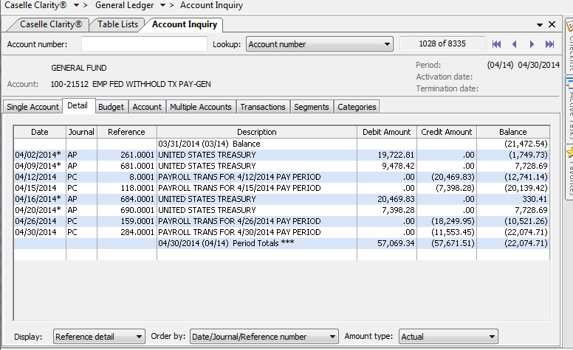 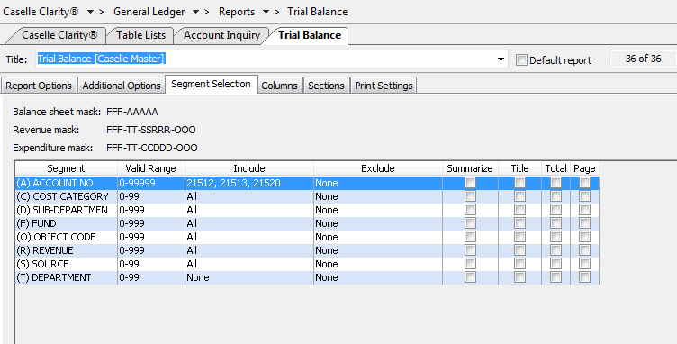

  - Run a Pay Code Transaction Report or Table List from Payroll to match the PC and PB amounts 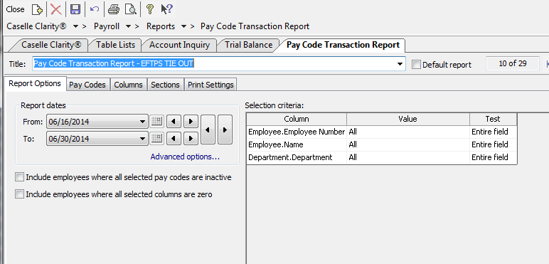 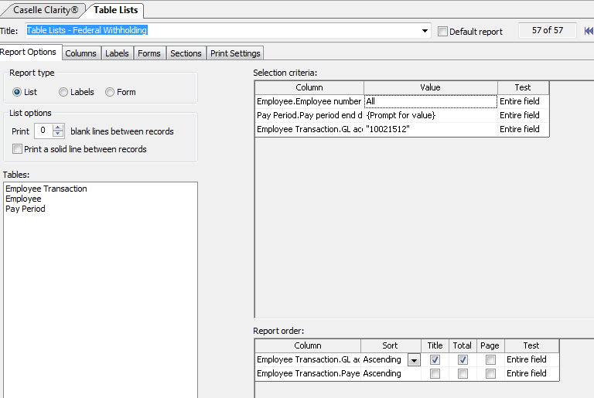 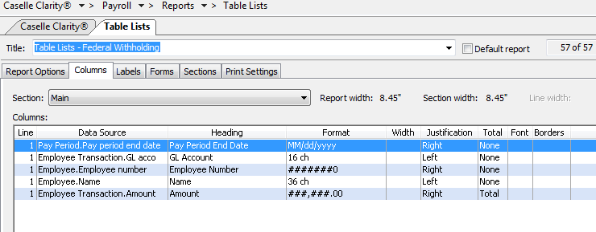 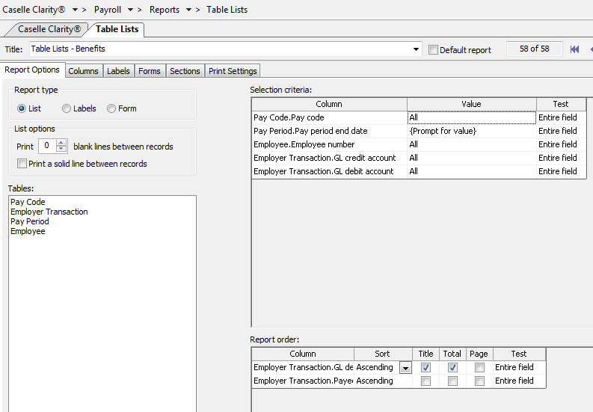 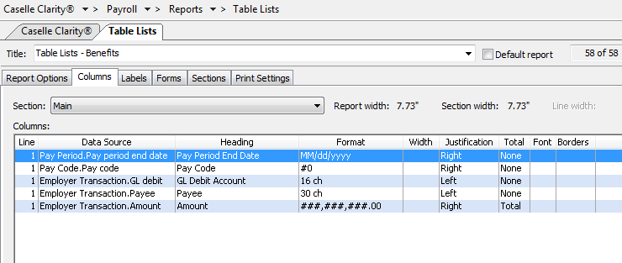
  - Show/track reconciliation 